1. Which functions and used to take input and show output in

PROLOG? Write a program to input your name from keyboard and

display it on screen.

Sol)

input_name :-

write('Whats ur name: '),

read(Name),

write('Hello '),write(Name) ,nl.

Output

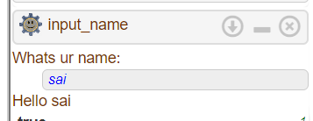

2. Write a PROLOG program for solving the following:

i) Implement a Menu Driven Calculator having functionalities like:

Addition, Subtraction, Multiply, Divide. Take two variables, input

it from keyboard then display the result in third variable on

screen.

Sol)

% Define the predicate to perform addition

add(A, B, C) :- C is A + B.

% Define the predicate to perform subtraction

sub(A, B, C) :- C is A - B.

% Define the predicate to perform multiplication

mul(A, B, C) :- C is A * B.

% Define the predicate to perform division

div(A, B, C) :- C is A / B.

% Define the main predicate to perform the calculator operations

calculator :-

write('Enter first number: '),

read(A),

write('Enter second number: '),

read(B),

write('Enter operation (add, sub, mul, div): '),

read(OP),

(OP = add -> add(A, B, C);

OP = sub -> sub(A, B, C);

OP = mul -> mul(A, B, C);

OP = div -> div(A, B, C)),

write('Result: '),

write(C).

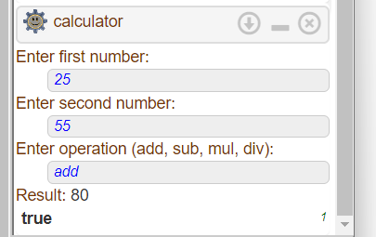

ii) Find maximum and minimum of 3 numbers, read numbers from

keyboard.

Sol)

% Define the predicate to find the maximum of three numbers

max3(A, B, C, Max) :-

Max is max(max(A, B), C).

% Define the predicate to find the minimum of three numbers

min3(A, B, C, Min) :-

Min is min(min(A, B), C).

% Define the main predicate to find the maximum and minimum

find_min_max :-

write('Enter first number: '),

read(A),

write('Enter second number: '),

read(B),

write('Enter third number: '),

read(C),

max3(A, B, C, Max),

min3(A, B, C, Min),

write('Maximum: '),

write(Max),

nl,

write('Minimum: '),

write(Min).

output

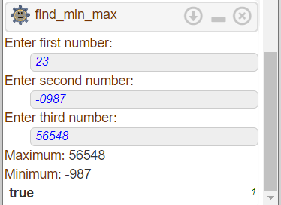

iii) A traffic signal system has rules as follows:

a. ODD date number plate vehicles are eligible for Monday,

Wednesday and Friday.

b. EVEN number plate vehicles are eligible for Tuesday,

Thursday and Saturday.

c. On Sunday all vehicles are eligible for running in traffic.

Read a vehicle number from keyboard & display its eligible days.

Sol)

% Define the predicate to determine if a vehicle number is odd or even

odd_even(VehicleNumber, Result) :-

(0 is VehicleNumber mod 2 -> Result = even;

Result = odd).

% Define the main predicate to check the eligibility of a vehicle

eligible_days :-

write('Whats ur vehicle number: '),

read(VehicleNumber),

odd_even(VehicleNumber, Result),

(Result = odd -> write('Eligible days: Monday, Wednesday, Friday');

Result = even -> write('Eligible days: Tuesday, Thursday, Saturday');

write('Eligible days: Sunday')).

Output

